# MSCD 600 Database Architecture

**Lab 2**

The purpose of this lab is to work with tables and learn more about the SQL*Plus environment.

Part 1

To show that you have successfully executed each step, you can either cut and paste the output on your screen and paste it into this Word document, or you can capture screen shots and paste them into this document. For information on how you will be evaluated, refer to the Labs Rubric on the last page of this document below.

Login to the database with your username before starting. To login, refer to the Course Resources\Student_Instructions_Static_Database_Xen_Servers.pdf which is also located in the Course Resources folder for easy access throughout this course.

**Note:** If you get part way through the lab and want to start over from scratch, run the following, or if you want to make sure these objects are dropped before you start then run the following:

drop table emp purge;

drop table dept purge;

drop sequence app_seq;

drop table inv purge;

drop table users_report_table purge;

It’s okay if you see an error saying that the object doesn’t exist.

--------------------------------------------------------------------

In SQL*Plus, -- starts a text comment on a line.

In SQL*Plus, REM starts a text comment on a line.

In SQL*Plus, /* Anything in here is a comment... */

--------------------------------------------------------------------

# Step 1: Verify you’re logged in as you and create two tables:

show user;

create table dept(dept_id number,

dept_name varchar2(20));

create table emp(emp_id number,

emp_name varchar2(20),

dept_id number);

desc dept;

desc emp;

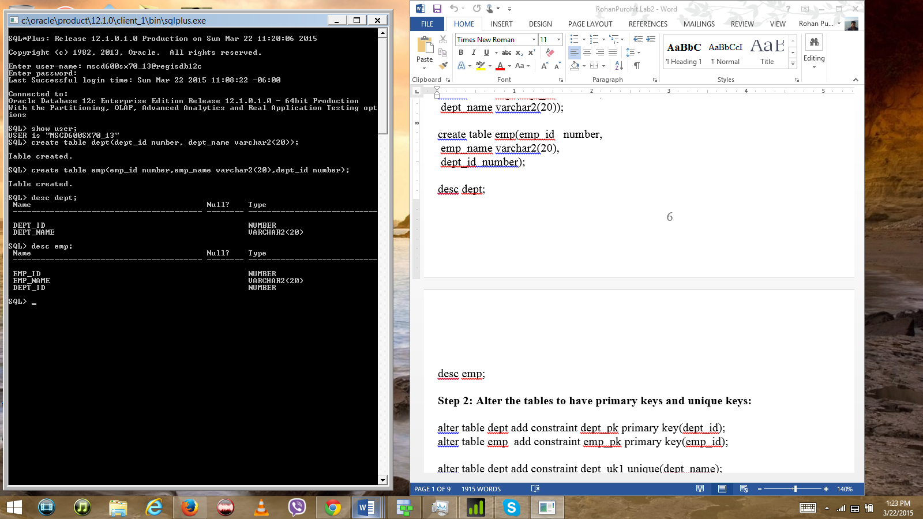

# Step 2: Alter the tables to have primary keys and unique keys:

alter table dept add constraint dept_pk primary key(dept_id);

alter table emp add constraint emp_pk primary key(emp_id);

alter table dept add constraint dept_uk1 unique(dept_name);

alter table emp add constraint emp_uk1 unique(emp_name);

select table_name, constraint_name, constraint_type from user_constraints;

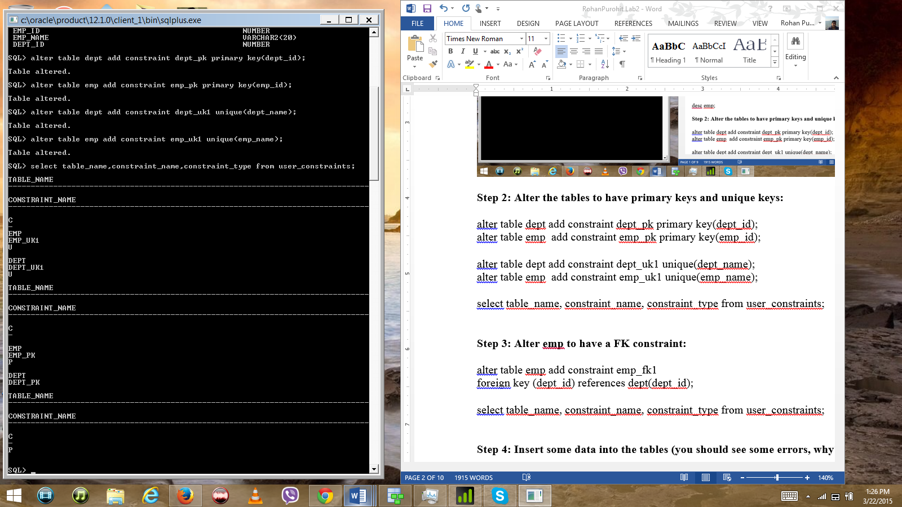

# Step 3: Alter emp to have a FK constraint:

alter table emp add constraint emp_fk1

foreign key (dept_id) references dept(dept_id);

select table_name, constraint_name, constraint_type from user_constraints;

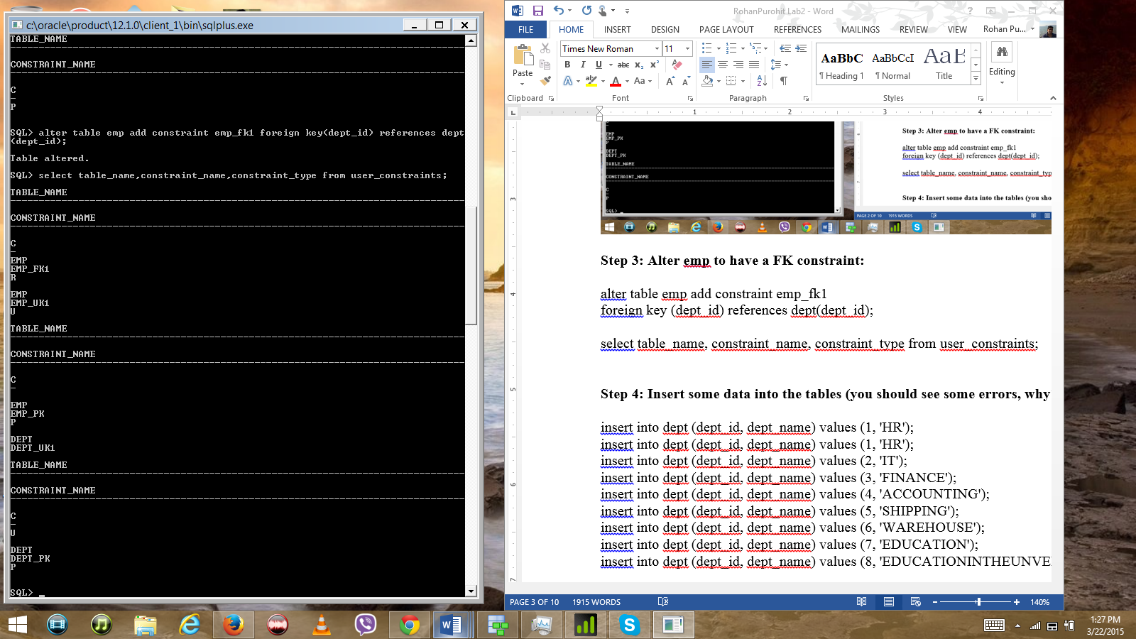

# Step 4: Insert some data into the tables (you should see some errors, why?):

insert into dept (dept_id, dept_name) values (1, 'HR');

insert into dept (dept_id, dept_name) values (1, 'HR');

insert into dept (dept_id, dept_name) values (2, 'IT');

insert into dept (dept_id, dept_name) values (3, 'FINANCE');

insert into dept (dept_id, dept_name) values (4, 'ACCOUNTING');

insert into dept (dept_id, dept_name) values (5, 'SHIPPING');

insert into dept (dept_id, dept_name) values (6, 'WAREHOUSE');

insert into dept (dept_id, dept_name) values (7, 'EDUCATION');

insert into dept (dept_id, dept_name) values (8, 'EDUCATIONINTHEUNVERSITY');

insert into emp (emp_id, emp_name, dept_id) values (100, 'Orton', 1);

insert into emp (emp_id, emp_name, dept_id) values (200, 'DJ', 2);

insert into emp (emp_id, emp_name, dept_id) values (300, 'Amy', 3);

insert into emp (emp_id, emp_name, dept_id) values (400, 'Harrison', 4);

insert into emp (emp_id, emp_name, dept_id) values (500, 'Vineetha', 5);

insert into emp (emp_id, emp_name, dept_id) values (600, 'Joshes', 3);

insert into emp (emp_id, emp_name, dept_id) values (700, 'Elaine', 3);

insert into emp (emp_id, emp_name, dept_id) values (700, 'Elaine', 3);

insert into emp (emp_id, emp_name, dept_id) values (800, 'Darl', 7);

-- Not assigned a departpment yet

insert into emp (emp_id, emp_name) values (900, 'Bob');

insert into emp (emp_id, emp_name) values (1000, 'Glenn');

insert into emp (emp_id, emp_name) values (1100, 'Glenn');

select * from dept;

select * from emp;

commit;

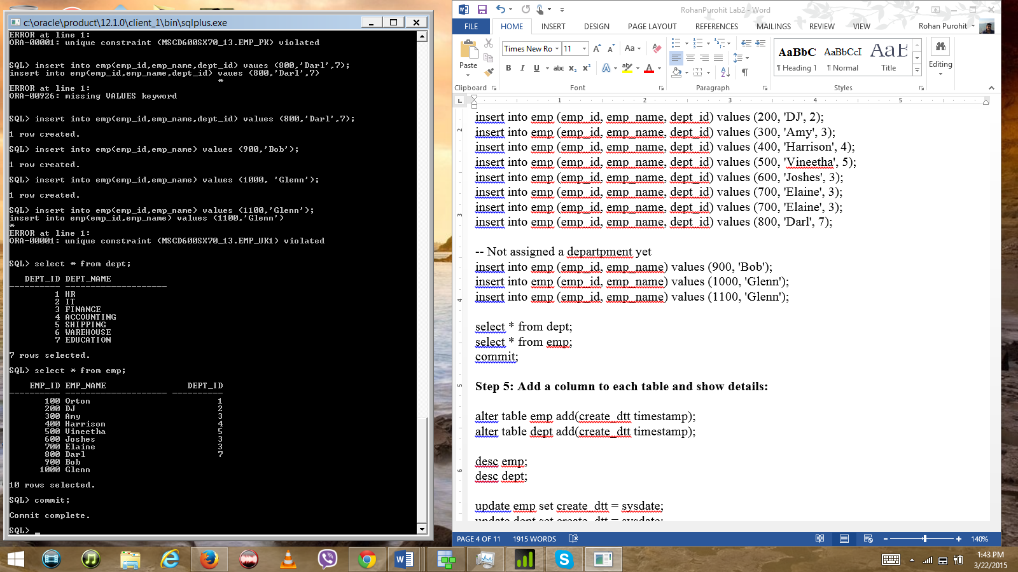

# Step 5: Add a column to each table and show details:

alter table emp add(create_dtt timestamp);

alter table dept add(create_dtt timestamp);

desc emp;

desc dept;

update emp set create_dtt = sysdate;

update dept set create_dtt = sysdate;

column create_dtt format a15

set pagesize 50

select * from emp;

select dept_name, trunc(create_dtt) from dept;

commit;

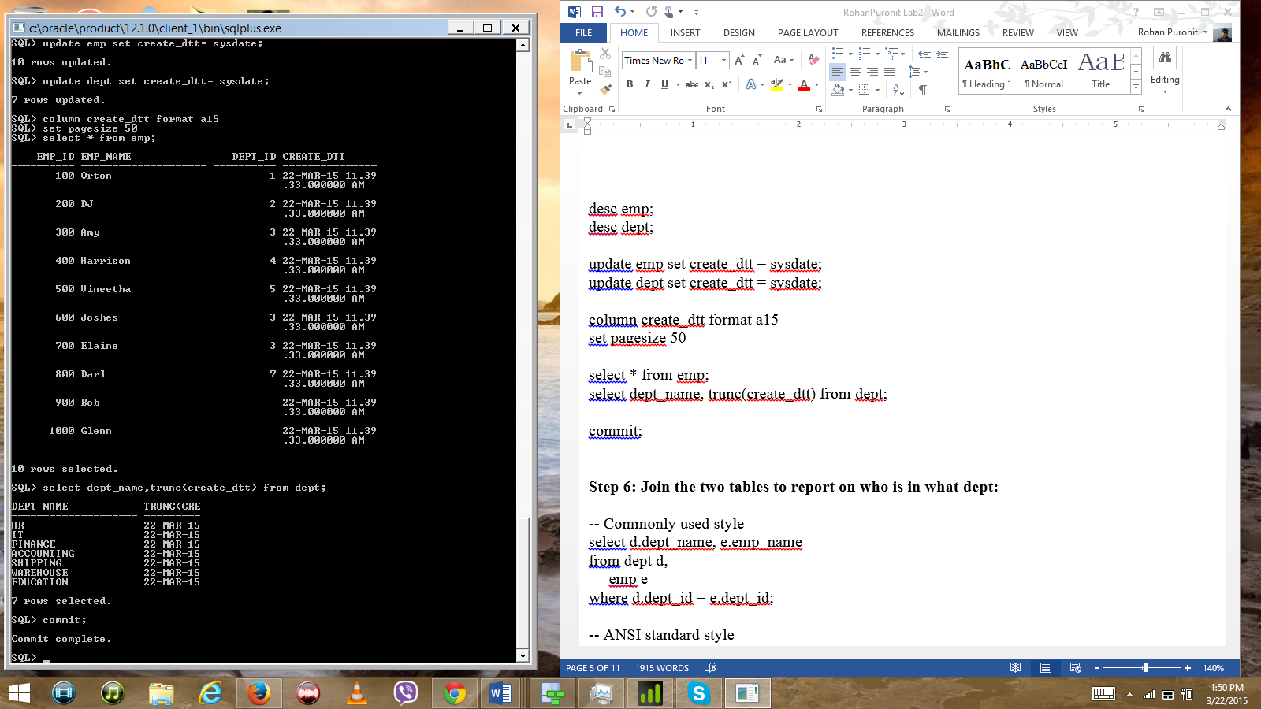

# Step 6: Join the two tables to report on who is in what dept:

-- Commonly used style

select d.dept_name, e.emp_name

from dept d,

emp e

where d.dept_id = e.dept_id;

-- ANSI standard style

select d.dept_name, e.emp_name

from dept d join emp e on(d.dept_id = e.dept_id);

-- ANSI using natural join clause

select dept_name, emp_name

from dept natural join emp;

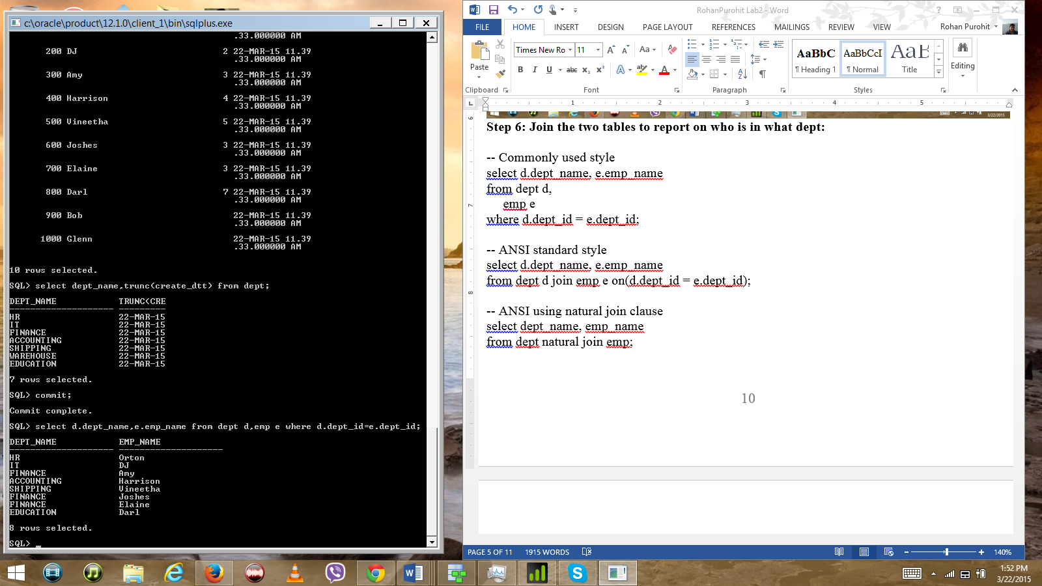

# Step 7: Drop the tables:

drop table dept;

-- What happened?

Error at Line 1: Unique/Primary keys in table referenced by foreign keys.

drop table emp;

drop table dept;

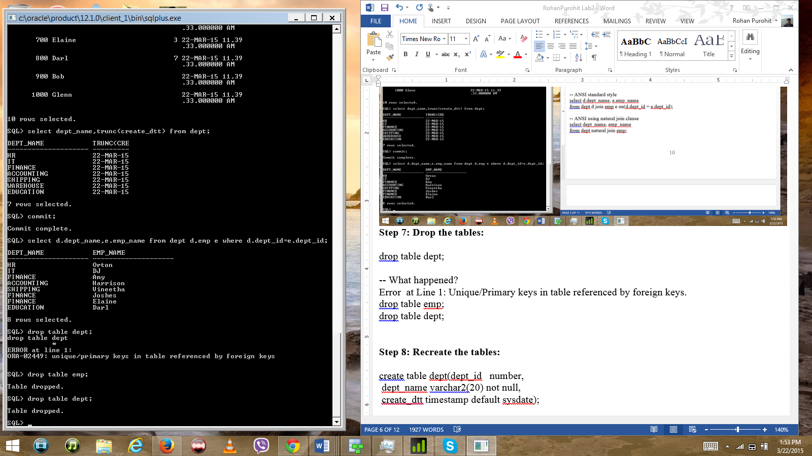

# Step 8: Recreate the tables:

create table dept(dept_id number,

dept_name varchar2(20) not null,

create_dtt timestamp default sysdate);

create table emp(emp_id number,

emp_name varchar2(20) not null,

dept_id number,

create_dtt timestamp default sysdate

);

desc dept;

desc emp;

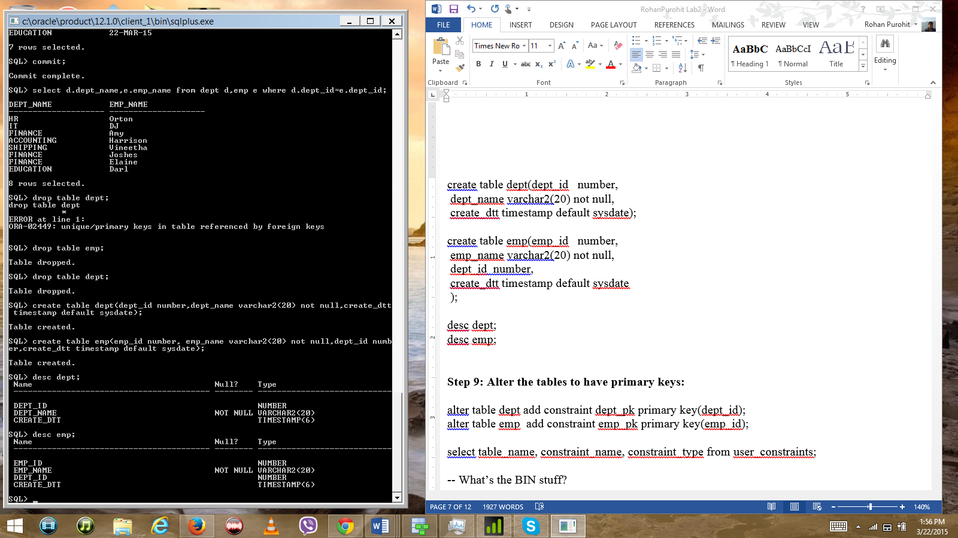

# Step 9: Alter the tables to have primary keys:

alter table dept add constraint dept_pk primary key(dept_id);

alter table emp add constraint emp_pk primary key(emp_id);

select table_name, constraint_name, constraint_type from user_constraints;

-- What’s the BIN stuff?

purge recyclebin;

select table_name, constraint_name, constraint_type from user_constraints;

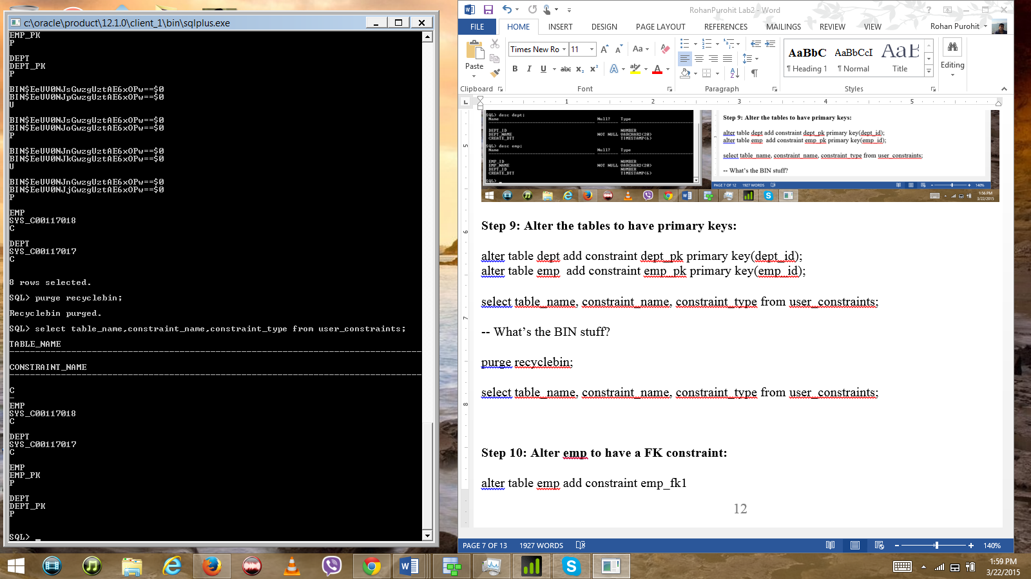

# Step 10: Alter emp to have a FK constraint:

alter table emp add constraint emp_fk1

foreign key (dept_id) references dept(dept_id);

select table_name, constraint_name, constraint_type from user_constraints;

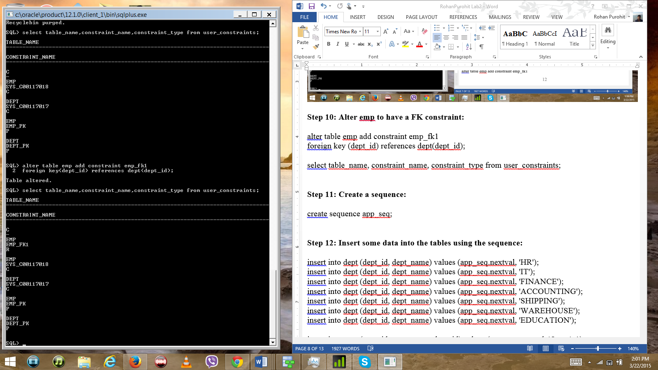

# Step 11: Create a sequence:

create sequence app_seq;

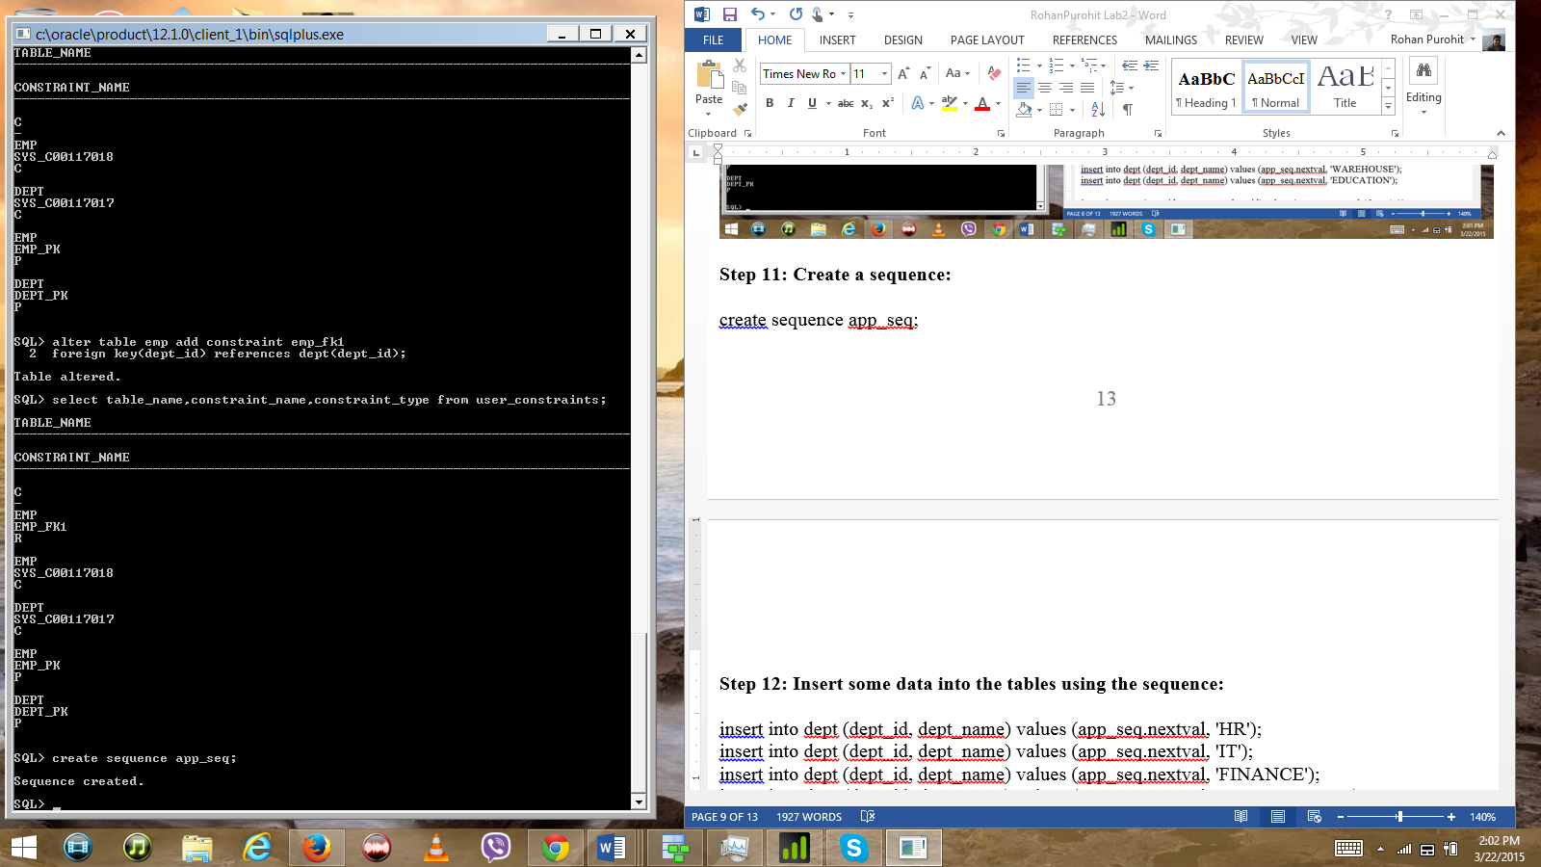

# Step 12: Insert some data into the tables using the sequence:

insert into dept (dept_id, dept_name) values (app_seq.nextval, 'HR');

insert into dept (dept_id, dept_name) values (app_seq.nextval, 'IT');

insert into dept (dept_id, dept_name) values (app_seq.nextval, 'FINANCE');

insert into dept (dept_id, dept_name) values (app_seq.nextval, 'ACCOUNTING');

insert into dept (dept_id, dept_name) values (app_seq.nextval, 'SHIPPING');

insert into dept (dept_id, dept_name) values (app_seq.nextval, 'WAREHOUSE');

insert into dept (dept_id, dept_name) values (app_seq.nextval, 'EDUCATION');

insert into emp (emp_id, emp_name, dept_id) values (app_seq.nextval, 'Orton', 1);

insert into emp (emp_id, emp_name, dept_id) values (app_seq.nextval, 'DJ', 2);

insert into emp (emp_id, emp_name, dept_id) values (app_seq.nextval, 'Amy', 3);

insert into emp (emp_id, emp_name, dept_id) values (app_seq.nextval, 'Harrison', 4);

insert into emp (emp_id, emp_name, dept_id) values (app_seq.nextval, 'Vineetha', 5);

insert into emp (emp_id, emp_name, dept_id) values (app_seq.nextval, 'Joshes', 3);

insert into emp (emp_id, emp_name, dept_id) values (app_seq.nextval, 'Elaine', 3);

insert into emp (emp_id, emp_name, dept_id) values (app_seq.nextval, 'Darl', 7);

select dept_id, dept_name, trunc(create_dtt) from dept;

select emp_id, emp_name, trunc(create_dtt) from emp;

select dept_id, emp_name from emp where dept_id = 3;

select emp_id, emp_name from emp where emp_id < 15;

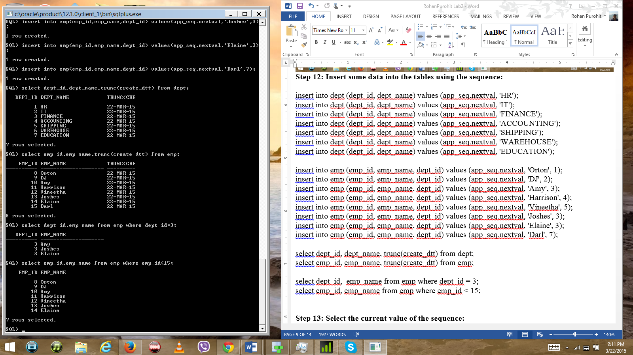

# Step 13: Select the current value of the sequence:

select app_seq.currval from dual;

select app_seq.nextval from dual;

select app_seq.currval from dual;

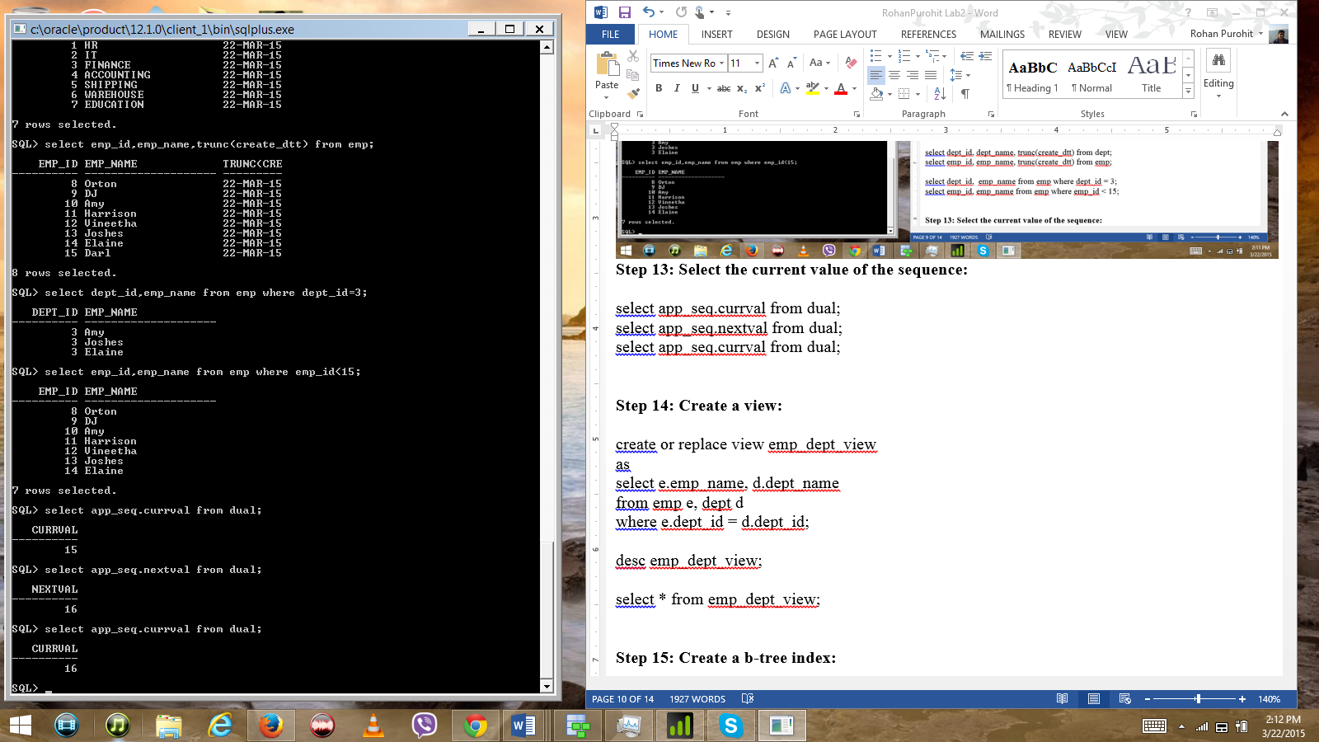

# Step 14: Create a view:

create or replace view emp_dept_view

as

select e.emp_name, d.dept_name

from emp e, dept d

where e.dept_id = d.dept_id;

desc emp_dept_view;

select * from emp_dept_view;

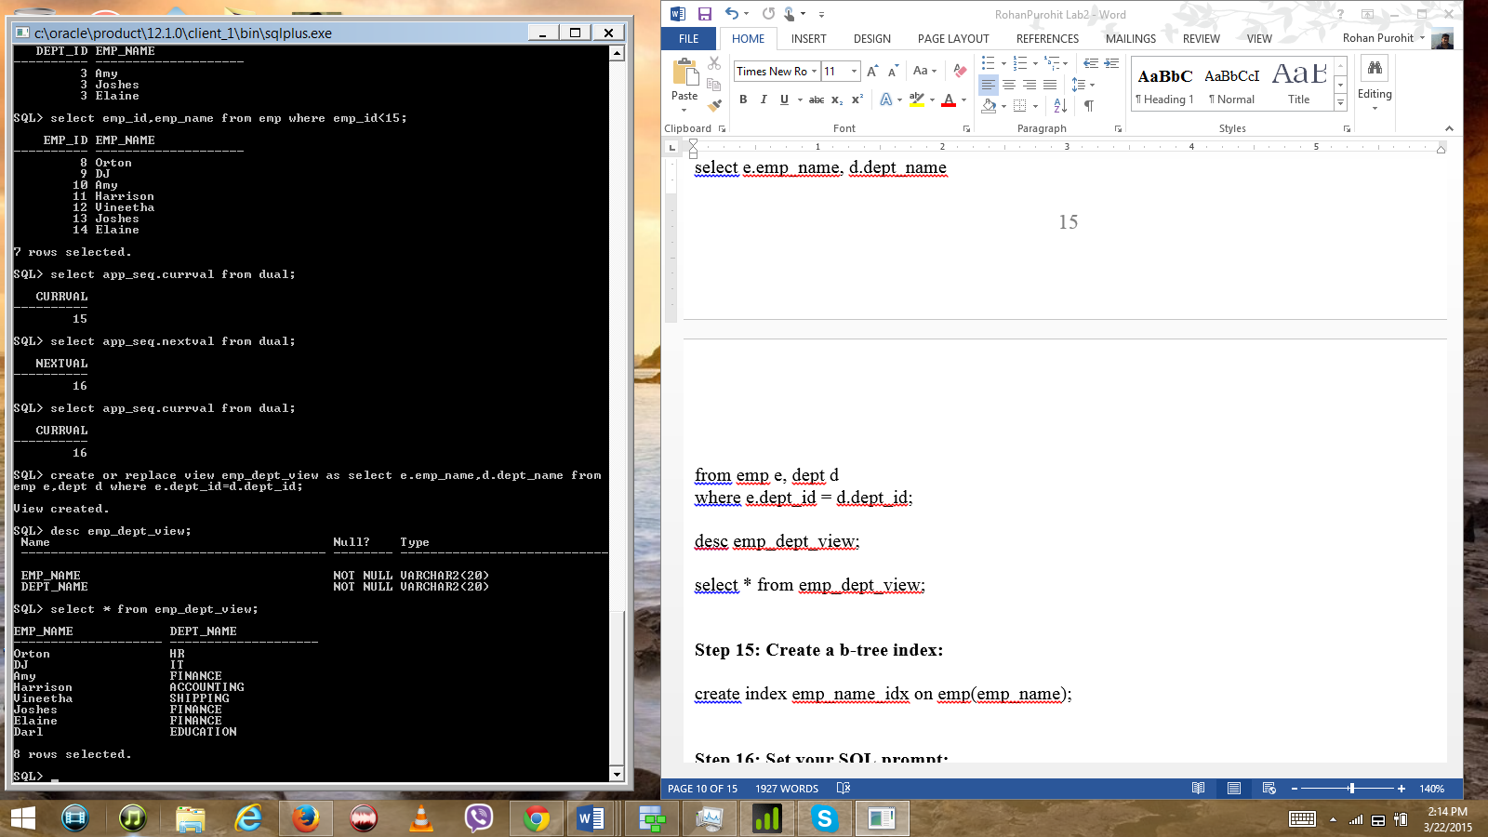

# Step 15: Create a b-tree index:

create index emp_name_idx on emp(emp_name);

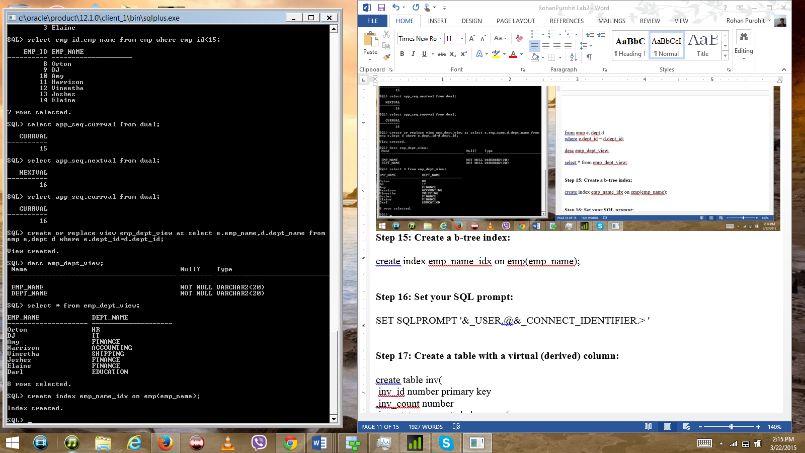

# Step 16: Set your SQL prompt:

SET SQLPROMPT '&_USER.@&_CONNECT_IDENTIFIER.> '

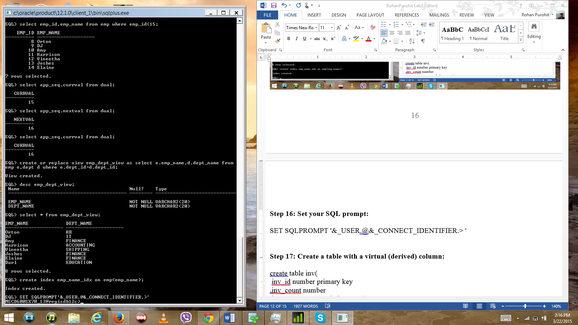

# Step 17: Create a table with a virtual (derived) column:

create table inv(

inv_id number primary key

,inv_count number

,inv_status generated always as(

case when inv_count <= 100 then 'GETTING LOW!'

when inv_count > 100 then 'OKAY, RELAX'

end)

);

set lines 80

desc inv;

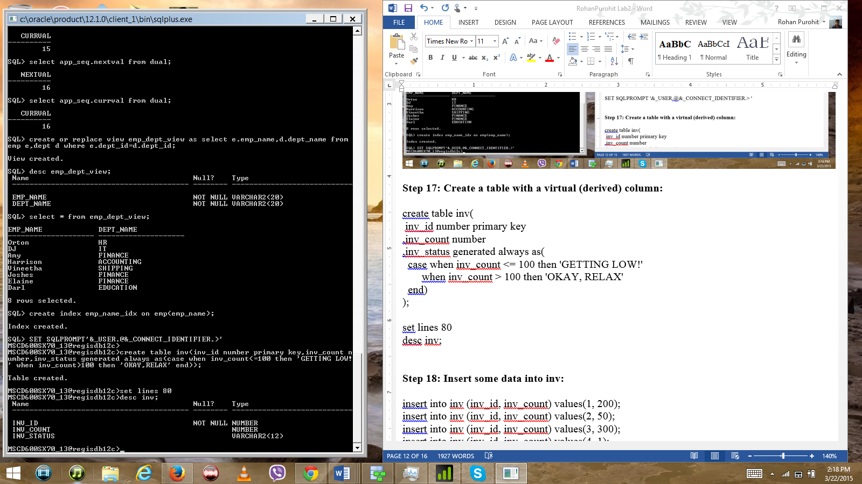

# Step 18: Insert some data into inv:

insert into inv (inv_id, inv_count) values(1, 200);

insert into inv (inv_id, inv_count) values(2, 50);

insert into inv (inv_id, inv_count) values(3, 300);

insert into inv (inv_id, inv_count) values(4, 1);

insert into inv (inv_id, inv_count) values(5, 5000);

insert into inv (inv_id, inv_count) values(6, 250);

select * from inv;

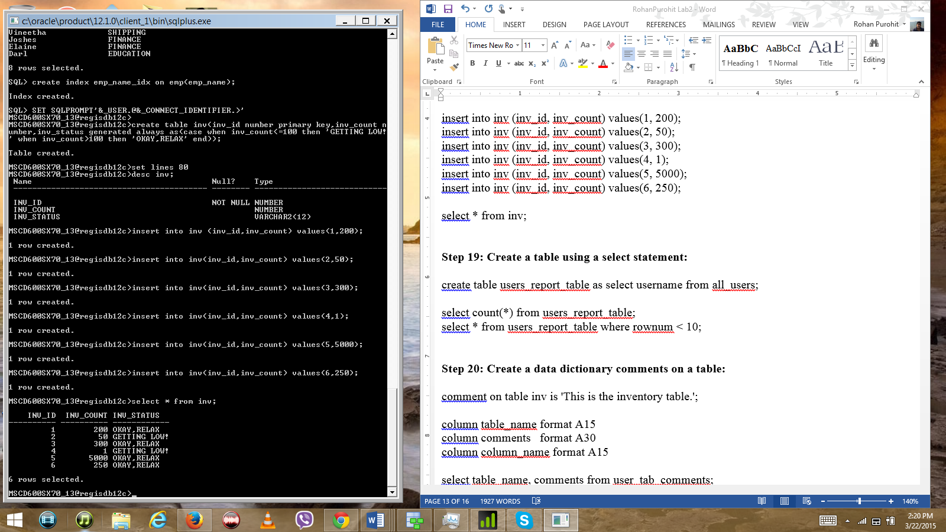

# Step 19: Create a table using a select statement:

create table users_report_table as select username from all_users;

select count(*) from users_report_table;

select * from users_report_table where rownum < 10;

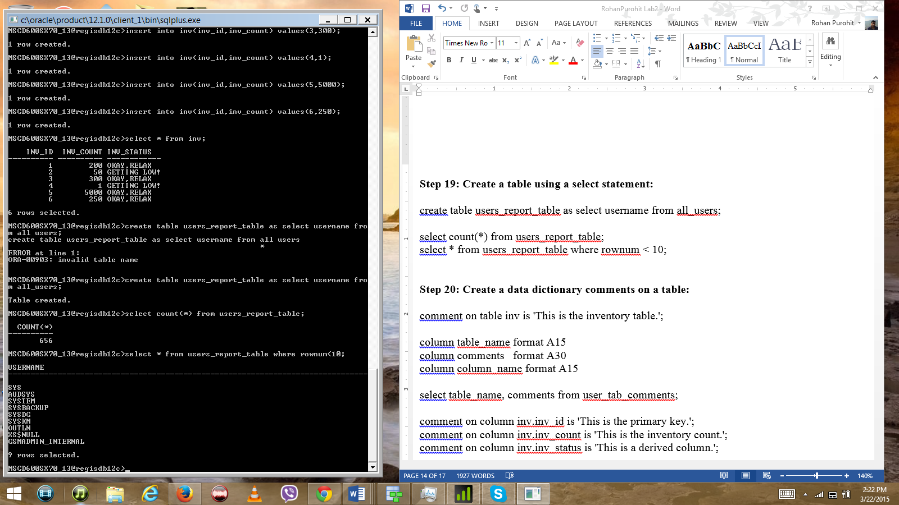

# Step 20: Create a data dictionary comments on a table:

comment on table inv is 'This is the inventory table.';

column table_name format A15

column comments format A30

column column_name format A15

select table_name, comments from user_tab_comments;

comment on column inv.inv_id is 'This is the primary key.';

comment on column inv.inv_count is 'This is the inventory count.';

comment on column inv.inv_status is 'This is a derived column.';

select table_name, column_name, comments from user_col_comments;

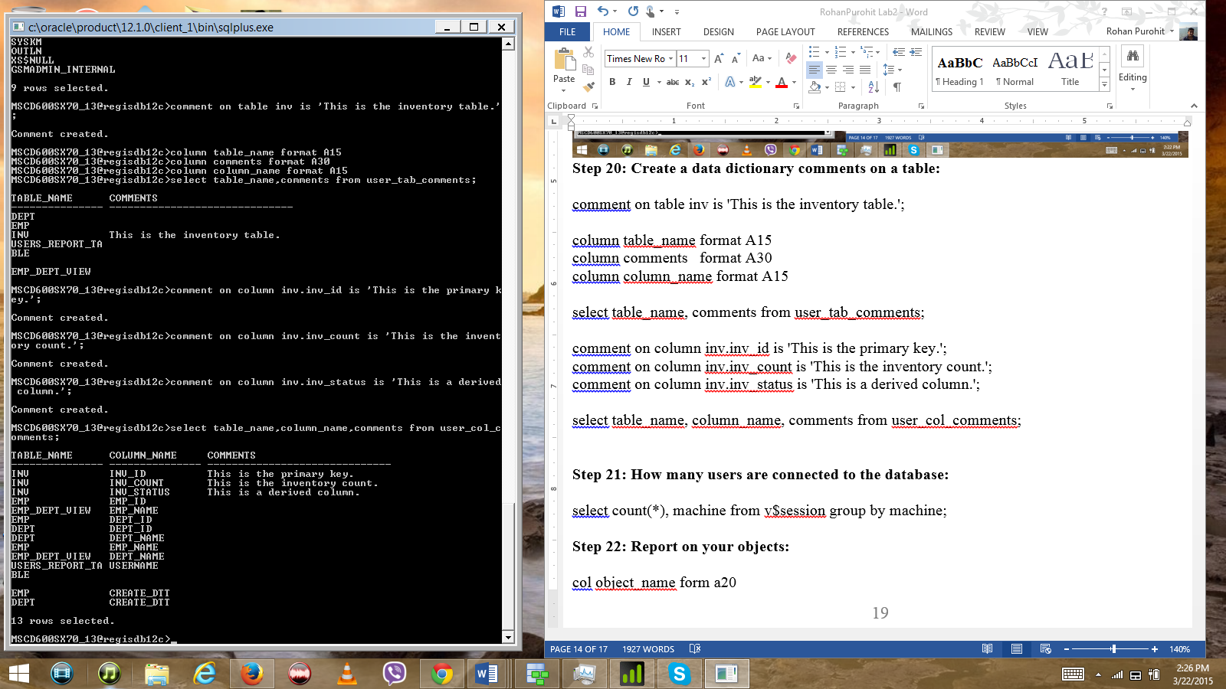

# Step 21: How many users are connected to the database:

select count(*), machine from v$session group by machine;

# Step 22: Report on your objects:

col object_name form a20

col object_type form a15

col table_name form a20

col tablespace_name form a20

col index_name form a20

set linesize 132

select object_name, object_type from user_objects;

select table_name, tablespace_name from user_tables;

select index_name, tablespace_name from user_indexes;

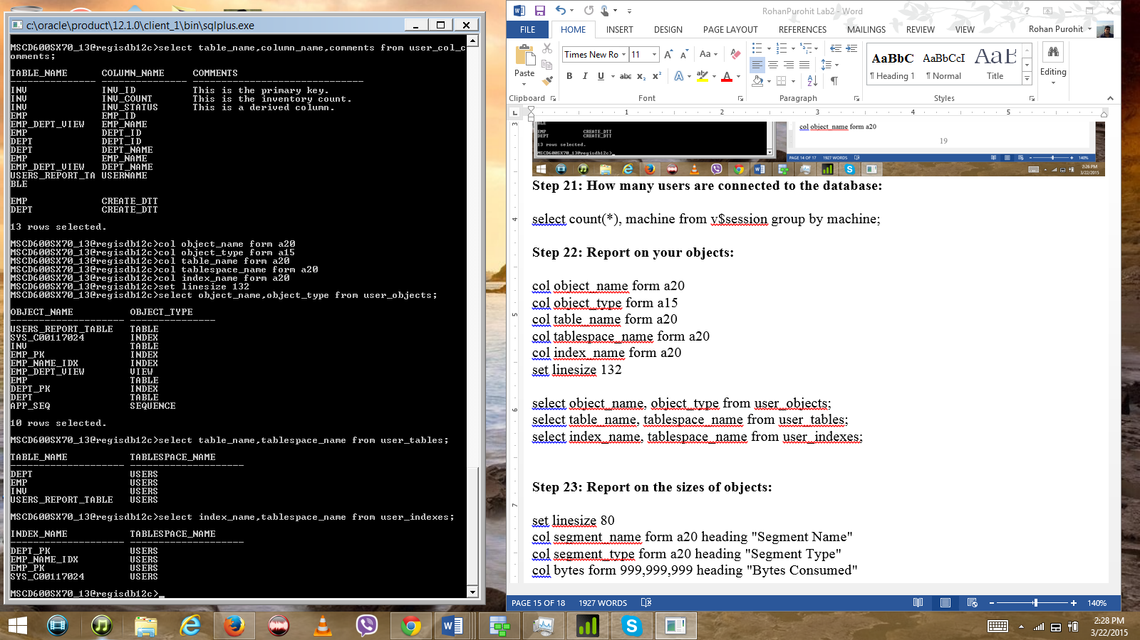

# Step 23: Report on the sizes of objects:

set linesize 80

col segment_name form a20 heading "Segment Name"

col segment_type form a20 heading "Segment Type"

col bytes form 999,999,999 heading "Bytes Consumed"

select segment_name, segment_type, bytes from user_segments;

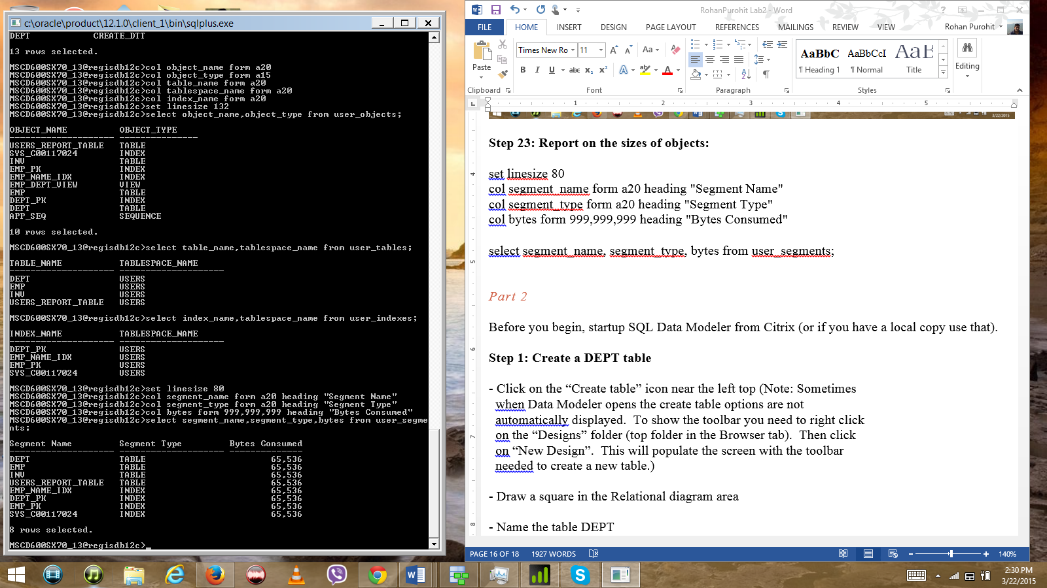

Part 2

Before you begin, startup SQL Data Modeler from Citrix (or if you have a local copy use that).

# Step 1: Create a DEPT table

- Click on the “Create table” icon near the left top (Note: Sometimes

when Data Modeler opens the create table options are not

automatically displayed. To show the toolbar you need to right click

on the “Designs” folder (top folder in the Browser tab). Then click

on “New Design”. This will populate the screen with the toolbar

needed to create a new table.)

- Draw a square in the Relational diagram area

- Name the table DEPT

- Click on “columns”

- Add a column named DEPT_ID (click on green add column arrow)

a) Make its datatype logical

b) Make its type numeric

c) Click on the PK box to make this the primary key

- Add a column named DEPT_NAME (click on green add column arrow)

a) Make its datatype logical

b) Make its type varchar

# Step 2: Create an EMP table

- Click on the “Create table” icon near the left top

- Draw a square in the Relational diagram area

- Name the table EMP

- Click on “columns”

Add a column named EMP_ID (click on green add column arrow)

a) Make its datatype logical

b) Make its type numeric

c) Click on the PK box to make this the primary key

Add a column named EMP_NAME (click on green add column arrow)

a) Make its datatype logical

b) Make its type varchar

# Step 3: Click on the FK icon

- Click on the DEPT table

- Then click on the EMP table

- Accept the defaults and click OK

# Step 4: Click on the Generate DDL icon (looks like a small datastore object on the top right).

- Click on Generate

- Accept defaults and click OK

# Step 5: Cut and paste the output into this document:

- Generated by Oracle SQL Developer Data Modeler 4.0.0.833

-- at: 2015-03-22 12:45:41 MDT

-- site: Oracle Database 11g

-- type: Oracle Database 11g

CREATE

TABLE DEPT

(

DEPT_ID NUMBER NOT NULL ,

DEPT_NAME VARCHAR2

) ;

ALTER TABLE DEPT ADD CONSTRAINT DEPT_PK PRIMARY KEY ( DEPT_ID ) ;

CREATE

TABLE EMP

(

EMP_ID NUMBER NOT NULL ,

EMP_NAME VARCHAR2 ,

DEPT_DEPT_ID NUMBER NOT NULL

) ;

ALTER TABLE EMP ADD CONSTRAINT EMP_PK PRIMARY KEY ( EMP_ID ) ;

ALTER TABLE EMP ADD CONSTRAINT EMP_DEPT_FK FOREIGN KEY ( DEPT_DEPT_ID )

REFERENCES DEPT ( DEPT_ID ) ;

-- Oracle SQL Developer Data Modeler Summary Report:

--

-- CREATE TABLE 2

-- CREATE INDEX 0

-- ALTER TABLE 3

-- CREATE VIEW 0

-- CREATE PACKAGE 0

-- CREATE PACKAGE BODY 0

-- CREATE PROCEDURE 0

-- CREATE FUNCTION 0

-- CREATE TRIGGER 0

-- ALTER TRIGGER 0

-- CREATE COLLECTION TYPE 0

-- CREATE STRUCTURED TYPE 0

-- CREATE STRUCTURED TYPE BODY 0

-- CREATE CLUSTER 0

-- CREATE CONTEXT 0

-- CREATE DATABASE 0

-- CREATE DIMENSION 0

-- CREATE DIRECTORY 0

-- CREATE DISK GROUP 0

-- CREATE ROLE 0

-- CREATE ROLLBACK SEGMENT 0

-- CREATE SEQUENCE 0

-- CREATE MATERIALIZED VIEW 0

-- CREATE SYNONYM 0

-- CREATE TABLESPACE 0

-- CREATE USER 0

--

-- DROP TABLESPACE 0

-- DROP DATABASE 0

--

-- REDACTION POLICY 0

--

-- ERRORS 0

-- WARNINGS 0

**MSCD 600 Database Architecture**

**Labs Rubric**

|  |  |
| --- | --- |
| **Grade** | **Rubric: Labs** |
| A  90-100% | -The lab work is technically sound  -The lab work addresses the criteria and exceeds the minimum requirements for the lab assignment.  -Met submission deadline.  - The deliverable format meets all requirements.  -Each item is clearly delineated and easy to follow.  -The submitted work is free from errors. |
| B  80-89% | -The lab work is technically sound  -The lab work addresses the criteria and meets the minimum requirements for the lab assignment.  -Met submission deadline.  - The deliverable format meets all requirements.  -Most items are clearly delineated and easy to follow.  -The submitted work has one to two errors. |
| C  70-79% | -The lab work is technically sound  -The lab work addresses the criteria and meets the minimum requirements for the lab assignment.  -Met submission deadline.  - The deliverable format meets most requirements.  -Most items are clearly delineated and easy to follow.  -The submitted work has more than two errors. |
| D  60-69% | -The lab work is not technically sound  -The lab work addresses the criteria and meets some of the minimum requirements for the lab assignment.  -Met submission deadline.  - The deliverable format meets some requirements.  -Few items are clearly delineated and easy to follow.  -The submitted work has more than three errors. |
| F  Less than 60% | -The lab work is not technically sound  -The lab work does not meet the base criteria nor the minimum requirements for the lab assignment.  -Did not meet submission deadline.  -The deliverable format meets some requirements.  -Few items are clearly delineated and easy to follow.  -The submitted work has more than four errors. |